8/25/2014

**Stefan Vasilev**

The university of st andrews

Insense Code Generation Tool and Integrated Development Environment (IDE)

130021081



School of Computer Science, University of St Andrews, the

The following project is submitted to fulfill the requirements for the master degree of M.Sc. in “Software Engineering”

Declaration



With that declaration I hereby certify that the dissertation has been fully composed by me and it has not been submitted in any previous applications. The project was developed by myself at the University of St. Andrews, school of Computer Science under the supervision of Dr. Dharini Balasubraniam and Dr. Johnathan Lewis.

With submission of the project report to the University of St Andrews, I permitted for its future use in accordance with the regulations of the University Library. I also give permission it to be published partially and used by future specialists and students. I fully retain the copyright over this work.

Acknowledgements



Words cannot describe how deeply grateful am I to my supervisors Jon and Dharini for their enormous effort spent to listen to my ideas and supervise and guide me throughout the whole development process of that thesis. My supervisors always came up with excellent suggestions and I really do hope that I did them in the best way possible.

They were always there – available to help me, stay with me and encouraged me during the entire process. I also would to thank to Maggie Winton from the student services for her deepest appreciation and encouragements.

Also, thanks to my mom without whom I would not have the motivation and willingness to be here and to submitting this MSc project. I also would like to express my deepest thanks to my dear friend Mariana Goushleva who was reading and reading my stuff and correcting it.

Last but not least, I would like to thank to Jairus Donald Howdek, my partner for this project. At some period of time, the things between us were a bit rocky but he was an excellent partner and helpED me in a lot of moments.

Abstract



Software Engineering is a new and modern discipline which aims to build reliable and sustainable software products that satisfy the required service or set of services. Model Driven Development is another step to automation of the process and with generated the functional, reliable and correct source code, helps to save time and allows the professionals to spend their effort on the problem instead of coding.

The initial proposal of the dissertation was separated in two parts, one of them creating models, the other one translates them into source code. This project explains the intermediate notation in which models are represented, and generates the code from it. In the last chapters, the graphical user interface and some of the most important decisions, are present. The implementation is made on Java and Eclipse, and the intermediate notation is using XML.

Finally, the dissertation ends with a conclusion, recommendations and constraints applied to the software implementation due to the limited amount of time. Some of the constrains are related to unsupported language features such as exception handling and missing operators. Recommendations concern mainly reverse engineering.

Contents

**1.1.** Aims and Objectives 7

**1.2.** Primary Objectives 7

1.2.1. Intermediate notation: 7

1.2.2. Design and Implement an Insense code generator 7

1.2.4. Conformance checking 7

1.2.5. Build a model and provide a detailed validation process 8

**1.3.** Secondary Objectives 8

1.3.1. Integrated Development Environment (IDE): 8

1.3.2. Reverse Engineering 8

**1.4.** Tertiary Objectives 8

1.4.1. Intellisence 8

1.4.2. Plugin for Eclipse 8

**1.5.** Approach 8

**1.6.** Contributions and Achievements 8

**1.7.** Personal achievements: 8

1.7.1. Researching, designing and implementing Intermediate notation (including initial documentation guide). 8

1.7.2. Identifying the essential functional, non – functional and domain specific requirements. 8

1.7.3. Insense code generation according to input model 8

1.7.4. Graphical User Interface implementation with an addition of Intellisence 8

1.7.5. Develop incrementally several intermediate language examples for verification purposes 8

1.7.6. Producing document that contains the initial Insense source code for possible comparison and evaluation of the proposed system. 8

**1.8.** Group achievements: 9

1.8.1. Validation of the intermediate notation. Updating and adding new statements. 9

1.8.2. Models preparation for the generated code. 9

1.8.3. Definition of the conformance checking rules of XML schema for the intermediate notation validation. 9

1.8.4. Modified Insense examples that need to be compiled within a particular environment UNIX, Insense OS, etc. 9

1.8.5. Additional contributions: 9

1.8.6. Developing the ability of the intermediate notation syntax to generate additional data structures that were not proposed in the model and generate them – procedures, arrays, constructor with parameters. 9

1.8.7. Providing generic templates for radio communication. 9

2.1 Background 10

2.1.1 Wireless Sensor Networks 10

2.1.3 Code Generation Strategies 14

**2.2** Relevant Technologies 15

2.2.1. Java 15

2.2.2. XML 15

Chapter 3: Software Requirements Specification 17

**3.1 Essential Product Functionality** 17

**3.2 General Information** 17

**3.3 Operating environment** 17

**3.4 Quality – Attribute Requirements and Design Constrains** 17

**3.5 Functional Requirements** 18

**3.6 Non – functional requirements** 19

Chapter 4: Intermediate notation 20

**4.1 Factors influencing decision to use Intermediate Notation** 20

**4.2 XML language as an intermediate notation** 20

**4.3 XML and conformance checking** 20

**4.4 Intermediate notation essentials** 21

**4.5 Essential computational units** 21

**4.6 Validation of the XML intermediate notation** 24

Chapter 5: Conformance Checking 25

5.1 Java and XML conformance techniques 25

5.2 XML schema 25

5.3 Internal Validation 27

Chapter 6: Project Methodology 28

6.1 Agile, Iterative and Waterfall methodologies 28

6.2 Software Team Work Process 29

6.3 Software Prototyping 29

6.4 Project Management Techniques 29

6.5 Conclusion 30

Chapter 7: System Design 31

7.1 Planning stage 31

7.2 Architecture specification 33

7.3 Logical view 34

7.4 Development view 36

7.5 Process view 37

7.6 Deployment view 38

7.7 Use Case Diagrams 39

Chapter 8: System Implementation 41

**8.1 Utility classes** 41

**8.2 Insense Code Generation** 50

**8.3 Reverse Engineering** 50

**8.4 Internode communication** 51

**8.5 Graphical User Interface** 52

**8.6 Code convention** 52

Chapter 9: Testing and evaluation 54

**9.1 Testing methodologies** 54

**9.2 Evaluation** 55

**9.3 Quality Attributes Evaluation** 55

Chapter 10: Conclusions 57

**10. 1 Future work and improvements** 57

**10.2 Limitations** 57

**10.3 Group work experience** 58

**10.4 Conclusions** 58

Reference section: 60

60

Chapter 1: Introduction



The core goal of the project is to design and implement a code generator tool that takes generated source code from Wireless Sensor Networks UML models and generates Insense [1] source code.

Insense is a high level programming language developed at the University of St Andrews. The language is designed specifically for wireless sensor network (WSN) applications. The programs of Insense are modelled as a compositions of components that interact via typed channels. Wireless sensor networks are used by experts of a particular domain field. The WSN users however are normally not programmers or computer science professionals. That could come as a problem when software development challenges occurs such as data parsing in real time or transmitting information. Other challenges include memory management, concurrency and synchronisation and event handling.

Code generator tool allows the domain professional to concentrates deal over modelling the problem instead of coding it. The code generation happens after an input follows specified intermediate notation is fed into the generation tool.

Meanwhile, if source code changes are necessary, the project contains a simple and user friendly integrated development environment that colouring key words and suggests them to the user.

## Aims and Objectives

The central aim of this dissertation is to produce compiled Insense source code according to a specific notation generated from a UML model. This problem often occurs in model-driven engineering. [3]

The project will be divided into two computational units. The top layer will create the models and the bottom layer will create the Insense source code. A modelling language is used to express the architectural design of the system and selected language is Unified Modelling Language (UML).[2] Once the model has been be created, the UML modelling tool will produce the specific input that contains all the necessary information for the bottom part to generate the source code.

## Primary Objectives

### Intermediate notation:

Propose a set of defined rules that describe a model with all the architectural properties and their values. The notation should be detailed enough to ensure mapping between the UML model and the Insense code. The objective is concerned with identifying violations, ambiguities and level of compatibility.

### Design and Implement an Insense code generator

The generator will take a representation of an Insense application as a UML model as input and will generate the corresponding Insense source code.

* + 1. Domain specifics

Identifying specific industry standards for code generation and adopt them.

### Conformance checking

Develop a conformance – checking framework (schema) to prevent incorrect code generation and detect all the violations in the notation.

### Build a model and provide a detailed validation process

Develop a model that will be verified and evaluate the proposed application and functionality.

## Secondary Objectives

### Integrated Development Environment (IDE):

Develop a simple graphical user interface that allows the user to open intermediate notation, validate it, generate Insense source code and compile it.

### Reverse Engineering

Develop a simple essential reverse-engineering strategy that allows generation of the essential computational units of Insense to Intermediate notation.

## Tertiary Objectives

### Intellisence

Provide a basic mechanism for identifying and colouring the key words and suggesting possible (guessing) keyword as well as formatting the source code.

### Plugin for Eclipse

Adapt the developed IDE from the secondary objectives as a plugin (graphical part embedded to Eclipse) to increase the compatibility between the projects (layers).

## Approach

The proposed solution involves analysing requirements, designing and building a parser that extracts the information from the intermediate notation, a list with clauses (a written statements from Insense language) that defines the correct syntax of the Insense programming language and a writer that creates the Insense file.

Once the primary goals have been accomplished, the secondary and tertiary goals will be implemented on top of them. The graphical user interface will be implemented with all the Intellisence aspects such as colouring key words and word-guessing.

Finally, the last two features to be implemented, the reverse-engineering and the eclipse plug-in, will use both generated source code and graphical user interface.

## Contributions and Achievements

According to the objectives mentioned above, the contributions and achievements are divided into three categories – group, personal and additional contributions:

## Personal achievements:

### Researching, designing and implementing Intermediate notation (including initial documentation guide).

### Identifying the essential functional, non – functional and domain specific requirements.

### Insense code generation according to input model

### Graphical User Interface implementation with an addition of Intellisence

### Develop incrementally several intermediate language examples for verification purposes

### Producing document that contains the initial Insense source code for possible comparison and evaluation of the proposed system.

## Group achievements:

### Validation of the intermediate notation. Updating and adding new statements.

### Models preparation for the generated code.

### Definition of the conformance checking rules of XML schema for the intermediate notation validation.

### Modified Insense examples that need to be compiled within a particular environment UNIX, Insense OS, etc.

## Additional contributions:

### Developing the ability of the intermediate notation syntax to generate additional data structures that were not proposed in the model and generate them – procedures, arrays, constructor with parameters.

### Providing generic templates for radio communication.



Chapter 2: Literature Review



The chapter briefly explains research, domain and application related to the project. The first two sections introduce the domain area (wireless sensor networks) and software development lifecycle. The following sections highlight the technologies used and the motivation behind these decisions. The chapter also outlines some of the problems that can occur in different phases of software development.

# Background

## 2.1.1 Wireless Sensor Networks

A sensor network is an infrastructure comprised of sensing or measuring information, computing it and sending it to a particular data warehouse The sensor network usually contains several components: an assembly of distributed sensors, a communication protocol (if the network is wireless, it does not contain interconnected network devices) with network devices, and a central point of information clustering with a set of resources that correlates and processES the input data. A wireless sensor network (WSN) [1][4] is a network of devices or nodes, which communicate and cooperate to achieve a common goal (for example, measure the temperature of the air or the chemicals concentrated in a particular type of soil). [4] Usually, the connected devices are very small and with constrained resources. Wireless sensor networks are used to generate, transmit and process data pertinent to the specific application domain. Normally, their users are not professional software engineers but experts in other fields such as ecology, geology, and physics. They tend to require a real time concurrent device, or a set of devices, to obtain data relevant to their work. [4] WSN is a very good example of a field where Model Driven Development is applicable because it allows the domain experts to concentrate their attention on the particular task instead of programming language, environments and other software engineering issues. [4]

2.1.2 Insense Programming Language

Insense is important to be priliminary understood . Insense is a programming language with object oriented syntax style. It is developed and maintained in the University of St. Andrews. The basic computational unit in Insense is the component. Instances of components may be created using constructors that are defined in a similar manner to Java, C# or C++. Components are strongly encapsulated and interact with each other via typed input and output channels. Conceptually, each component instance contains a single thread of control. The actions of this thread are called the component’s behaviour which is specified in a syntactic entity of the same name. The actions in behaviour repeat indefinitely until the component is stopped either by itself or by another component. [1]

The main goal of an Insense is to solve complex problems of Wireless Sensor Networks, especially memory management regarding to wireless sensor devices limited resources. Insense on the other hand, allows short and simple component based programs, made into threads with unique behaviour to address the concurrency and resources problems successfully. Each component, similarly to a class of C++ and Java,is independent computational unit allowing encapsulation of the information inside it.

Due to the time limitations, the code generator tool will not be able to generate every single Insense feature. Meanwhile, the generated programs must be correct according to the initial model , and compiled. To be achieved that goal, it is necessary a careful and reasonable approach of which computational units needs to be implemented, and which needs to be postponed for future work.

Insense addresses specific domain field – wireless sensor networks. The main computational unit is component that will be described below. Each component presents one or more interfaces. Each interface contains one or more channels that send and receive information. Each channel could be composed by a union of several types called struct. According to this short analysis of a basic Insense program, the following essential computational units are necessary to be approached and represented in depth:

Essential Computational Units:

* 1. Interface Types
  2. Components
  3. Instances of Components
  4. Connections
  5. Procedures

Each of the above selected elements will be analysed below. All of the important aspects and interactions will be presented. In chapter 4, it will be presented how the above described computational units are represented by the accepted intermediate notation.

Structure Types

Structure type is very similar to the one in C language. In Insense structure is a complex data type. It is a union or a grouped list of various other variable types capsulated in a single unit reachable by name. The structure type can contain other complex data types such as arrays and other structures. The keyword for creating a structure is ‘struct’. Figure 2.1 demonstrates the struct type in Insense:

Figure 2.1: Insense Struct Example

|  |
| --- |
|  |

The example represents a struct with a name ‘Sensor Reading’ with four fields of two integers and two real numbers.

Interface

Interface type in Insense is a compulsory language feature. By a design perspective, it is an abstract type that defines resources for communication (channels) that it hosts. Each interface in the language is implemented (present) by either one or more components. Figure 2.2 illustrates Insense interface.

Figure 2: Insense Interface Example

|  |
| --- |
|  |

The interface contains a name, for example ‘ISensorReader’ and one or many channels. The difference between the channel and the field of the structure type previously described ,is that channels require directions. The channels are described by both two complex (structure) and one primitive, types. The possible types of direction are ‘in’ that accepts information, and ‘out’ that sends it.

Component

Insense is a component based language which means that component is a starting executable point of every program. Components represent main functional units in the Insense code. They represent or implement interface and define the behaviour of the system. Figure 2.3 illustrates Insense component example.

Figure 2.3: Insense Component Example

|  |
| --- |
|  |

As the other language features, every component is described by name ‘SensorReader’. The component presents the interface ‘ISensorReader’ and contains a constructor (default one), which is the initial point of the component, and behaviour which is the logic. The component can also define a set of constructors, and not only one. Some of the constructors may have arguments.

Component behaviour

The behaviour is the part of the component that represents the main functionality. According to their importance and complexity, not all of the possible language features that a behaviour represents, will be implemented. Examples for features that will not be supported are exceptions or the operator select.

On the contrary, the most common and highly important constructs and operators would be supported. The system requirements have to include the following Insense functionality:

* Sending and receiving information on a channel
* Variable manipulations
* Instances
* Printing data
* Create in “if” clause
* Increment and decrement a field
* Calling a procedure

The most common operatorS in a components’ behaviour are send and receive. These two operators are setting up the direction of the transmitted information via presented channels. They actually connect wireless network devices. Figure 2.4 illustrates the component behaviour.

Figure 2.4: Insense component behaviour example

|  |
| --- |
|  |

The example also illustrates the syntax of print function which is very similar to the print function of C programming language. The other illustrated functionality is local instantiating of a component by calling the constructor with parameters and the increment of a component field.

Instances of Components

Components, similarly to the classes in object oriented programming ,are realised by a specific creation called instance object. The instances are created by subroutines called constructors. One component could be instantiated several times to represent behaviour related to the different channels. In the next section, it will be illustrated how the channels are connected to each other and that statement will make much more sense. Figure 2.5 demonstrates an instance of a component.

Figure 2.5: Insense Instance Example

|  |
| --- |
|  |

Component instances are created by calling the constructor of the component ‘SensorReader’ and a name of the instance.

Connections

Connections are special type of information exchange between the components. To be valid, the connection must be presented by a pair of two components, each one represented by channels, one for sending data and other for receiving it. For establishment of the connection, it is used a language keyword connect. One channel is possible to receive data from multiple connections. Figure 2.5 illustrates the connection type.

Figure 2.5: Insense connection example

|  |
| --- |
|  |

As it is demonstrated above, connections are established by giving the name of in ‘input’ channel of the instance ‘po’ to the out channel of ‘printChan’ of the instance ‘sr’.

## 2.1.3 Code Generation Strategies

In practice, wireless sensor networks are relatively typified by small and low-power devices, often called motes. The Mica2 mote, developed at the UC Berkeley, is one of the most popular sensor node designs. It is an embedded system and often involving techniques that are applied in embedded code generations.[5] The general phases include the pre-solve phase, a solver phase and a verification phase. The first phase, includes the problem description (intermediate language generated from UML), the code generation itself and passing the generated code to the compiler (see figure 2).

Figure 5 Code Generation Process

When the generation of the code is complete, solver phase will commence. There are several requirements the generated source code needs to fulfil. The generated source code must be format, colour and correct. According to Mattingley [12], the generation converts symbolic representation to compliable code. In the verification phase, two criteria must be assessed – computational speed and reliability. In other words, maximum execution time must be measured after testing a lot of problems that verify the performance as well. There are fundamental testing procedures that have to be applied:

- Reliability testing

- Acceptance testing.

An additional verification procedure that could have a lot of advantages is Model Based testing.This testing procedure verifies the input and output data according to a specific model. The generation strategy will be the same as with solver phase. Usually, according to Kelly and Tolvanen [6], code generation is supported by a framework that provides the common atomic implementations within the specific domain (in our case, Insense with Wireless Sensor Networks).

## Relevant Technologies

### Java

Among several widely used programming languages, both C# and Java have been chosen to build both the prototype and the application at a certain stage of the process. Java has been considered as a main language according to following advantages:]

* 1. Platform independence – the project was built on Linux and Mac OS. Unfortunately, C# and .Net are not officially supported for these two platforms.
  2. Both Java and C# are object oriented. However, Java compiles on eclipse-integrated development environment. Eclipse compatibility was required by the upper layer.
     + 1. Adoption in the industry: both C# and Java are widely adopted. Java is the most widely used programming language today. [8] [7]
       2. Open Source Libraries – both C# and Java have a wide variety of open source libraries. However, the Java open-source community is bigger, so that is another reason for selecting it.
       3. Practical experience - previous experience in both languages. That is the reason for building the application with them.

### XML

For the intermediate convention that transmits the information between the upper and bottom layers Extensible Markup Language (XML) was selected. XML originally was created to transport information.[9] The main advantage of XML is the ability to define specific tags that are close to Insense computational units. The other two huge advantages are that Papyrus models generate XML output. (reference) In this case, time will be dedicated for more extensive implementation of the language features and more generated models instead of looking for another output specification. Furthermore, Java as well as other modern languages propose an extensive support of reading, creating and writing XML documents.

* + 1. Eclipse

The Integrated Development Environment (IDE) chosen to implement Java code is Eclipse. It is an open-source and a platform independent software framework written in Java. Moreover, the upper layer and one of the objectives set up for that project also required Eclipse. Finally, eclipse is very well adopted by the software industry because it runs over all three of the widely used OS such as Windows, Linux and Mac OS.

* + 1. GIT

Git is a free open-source version of a control management system. It is widely used and designed to handle large, medium and small scale projects. The main three reasons for choosing Git instead of Microsoft Team Foundation and Mercurial are previous experience, extensive supporting materials on the official web site and free electronics e–book and, last but not least, the good compatibility and integration between Git and Eclipse. [10]

* + 1. Maven

Maven is a build process system that provides uniform builds and quality project information. It was selected because it follows the best practices for software development and provides additional tools for style checking. [11]



# Chapter 3: Software Requirements Specification



The chapter will provide the set of requirements concerning Insense code generation functionality, Intermediate notation transmitting the information from top layer and the Graphical User Interface accompanying the code generation. The chapter explains functional, and non-functional requirements.

### **3.1 Essential Product Functionality**

The application is recommendable to be able to generate syntactically correct and well formatted Insense source code. Moreover, it also is recommendable be able to reverse engineer on a basic level from Insense to an intermediate notation the essential computational data structures such as structure, component, interface, connect, channel, send, and receive. The intermediate notation has to be able to represent the information in precise and structured way that allows code generation. The graphical user interface that encapsulates the functionality should be simple, native and easy to navigate through the generated source code and intermediate notation.

### **3.2 General Information**

The selected method for requirements classification is similar to the methodology used in ADD or Attribute Driven Design.[20] The process involves classification of the requirements as they are divided into categories. Once divided, requirements are ranked according to their priority (represented as a pair of letters). The letters are as follows:

Table 3.1: Requirements classification overview

|  |  |
| --- | --- |
| Letter | Impact |
| L | Low |
| M | Medium |
| H | High |

The first part of the pair represents the importance to the system, the second one represents the impact over the implementation.

### **3.3 Operating environment**

The future product is expected to be used from the school of Computer Science at the University of St Andrews to produce the Insense Code from UML models. The application expects to run on Linux and Mac and to some extent on Windows.

### **3.4 Quality – Attribute Requirements and Design Constrains**

The following set of requirements reflect the quality attributes of the future application rather than its functionality.

Table 3.2: Quality attributes table

|  |  |  |  |  |
| --- | --- | --- | --- | --- |
| ID | Quality goal | Requirement Specification | Importance | Impact |
| 1. | Usability | The user should be able to select which file to be generated. | M | L |
| 2. | Compatibility | The system should be compatible with the upper layer. | M | M |
| 3. | Performance | The system must generate the code for an acceptable time according to the length of generated lines. | H | H |
| 4. | Compatibility | The system must be able to run on multiple operating systems. | L | L |

The Design Constrains are listed below:

1. For the sake of compatibility the system shall be implemented in Java and under Eclipse IDE.
2. The system should read only two file formats “.isf” and “.xml”. The above mentioned file formats could be the only file types that could be exported.

### **3.5 Functional Requirements**

The following section explains functional requirements. They capture what is the behaviour of the system. In other words tasks and functionality that code generation is required to perform.

Table 3.3: Functional Requirements Table

|  |  |  |  |
| --- | --- | --- | --- |
| ID | Requirement Specification | Importance | Impact |
| 1. | The system should accept both intermediate notation files and Insense files. | H | H |
| 2. | The system shall be able to perform a conformance checking validation before to generate the code. | H | H |
| 3.1. | The system has to generate the correct source code for Insense. | H | H |
| 3.2. | The system has to follow a defined set of rules to generate the correct intermediate notation. | M | M |
| 4. | The system shall be able to validate extracted information from the intermediate notation file. | H | H |
| 5. | The system shall be able to generate the correct XML source code. | H | H |
| 6. | The system shall be able to invoke a compiler to compile (build) the generated source code. | H | M |
| 7. | The system should prompt a window with the information from the compiler when the compilation phase finished. | M | L |
| 8. | The system shall be able to reverse at least the essential data structures from Insense to the intermediate notation. | M | H |
| 9. | In a case of detected violation the system should be prompt message to the user, including a valid pointer to the source of error presented in a user friendly and informative way. | M | M |
| 10. | The system should generate from the file only if following the defined schema. | H | H |
| 11. | The system should support generation of multiple input and output files. | L | L |
| 12. | If a code is not able to be generated the system must notify the user. | L | L |
| 13. | The user has to be able to select the destination where the generated file will be saved. | L | L |
| 14. | If the user does not specify where the file to be generated the system has to be able to create a default folder and generate the file in it. | M | L |
| 15. | If the user does not specify the file name the system has to be able to generate it with a default name. | M | L |
| 16. | The system should validate the files automatically or manually. | M | M |
| 17. | The system should be able to detect the key words and colouring them in a specific colour. | L | L |
| 18. | The system should be able to guess the key word and prompt it for the user. | L | L |
| 19. | The system should be able to display the intermediate notation and Insense files on the GUI. | M | M |

### **3.6 Non – functional requirements**

Table 3.4: Non - functional Requirements Table

|  |  |  |  |
| --- | --- | --- | --- |
| ID | Requirement Specification | Importance | Impact |
| 1. | The system be able to work stable when the incorrect file format is selected. | H | H |
| 2. | The graphical interface has to be easy to navigate through. | M | L |
| 3. | The user shall be able to select the desired Insense compiler version. | M | L |
| 4. | The system shall be documented and additional video materials shall be generated. | L | L |



# Chapter 4: Intermediate notation



The chapter explains the motivation for the intermediate notation, and the rules and concepts behind it. It also outlines why XML was selected for language for the intermediate notation as well as what rules were set for the XML schema (conformance checking). Explanation of the XML schema that validates the intermediate notation input files generated from the UML models is describe in next chapter. Finally, the chapter explains how the intermediate notation was validated throughout the whole process of development.

### **4.1 Factors influencing decision to use Intermediate Notation**

The architecture of the dissertation *UML Model to Code Generation for Wireless Sensor Networks* requires a defining an intermediate notation or set of rules that allows to transmit the information from top to bottom layer and vice versa. To define such a notation it is necessary to consider two key factors:

- Common Types: intermediate notation represents type definitions, specify how data type is defined and the possible values. This allows internal validation between the expected and input data. It also defines a set of rules which ensure that data types are written on a concrete enough level that reduces any possibility of ambiguity.

- Hierarchical order: the notation is supposed to be hierarchically structured to be able to contain nested elements. List of attributes such as type, name, values, etc. also need to be transmitted through the intermediate notation. Moreover, a good intermediate notation needs to be self-explanatory, readable and with finite number of elements. It also needs be able to represent complex hierarchical structures as simply as possible.

### **4.2 XML language as an intermediate notation**

Given the fact that intermediate notation requires hierarchical structure and that the project is going to convert UML to some other languages, the use of Extensible Markup Language (XML) is appropriate as the underlying convention and transporting of information. Moreover, the initial idea of the language of XML was to be used as a language that transmits information. [16] The main advantage of XML is the ability of the user to create tags that form a document structure. The other huge advantage is the ability to extract information using standardized XML parsers embedded in almost every modern object oriented language such C# and Java.

### **4.3 XML and conformance checking**

According to W3Schools [15], an XML schema defines the legal building blocks of an XML document. The main goal of the schema is to reduce the possibility of errors that appears in block and attribute. Also, the other goal of the schema is to reduce as much as possible the appearance of unknown elements and values. In other words, the notation and schema should:

1. XML schema defines elements, attributes and the order that they must appear in a particular document.
2. XML schema defines which block is about to have child elements, their order and attributes.
3. XML schema defines when is possible for some of the attributes to be empty, data types and possible expected (default) values.
4. XML schema defines which attributes and elements are compulsory and which are optional.
5. In order to anticipate changes the schema must be as abstract as possible but concrete enough so it would not allow ambiguity. In this case XML notation and schema should:
6. XML schema allows additional parameters.
7. XML schema allows easy modifications.
8. XML schema is written in XML.
9. XML schema supports data types, objects, components and other structures.

Many of the requirements concern different levels of validation and, respectively, verification of the data. One of the biggest advantages of a XML schema is ability to describe allowable content, validate data correctness, put restrictions over it and describe precisely the data conversion if it is required.

### **4.4 Intermediate notation essentials**

This section presents a brief overview of the intermediate notation and how the information is structured and represented. The section also outlines the essential computational units in Insense programming language and their representation in the notation.

1. Data types are specified in an attribute type. Six data types are distinguished in the intermediate notation:

* Integer
* Boolean
* Real
* Unsigned integer
* Array
* String

### **4.5 Essential computational units**

#### Interface and channels

Figure 4.1: Insense Source Code – Interface and channels example

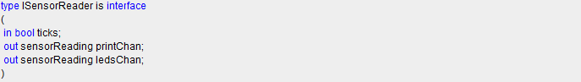

Figure 4.2: Intermediate Notation – Interface and channel example

|  |
| --- |
| <interface>  <attribute name = *"ISensorReader"* />  <channel type = *"bool"* name = *"ticks"* direction = *"in"*/>  <channel type = *"sensorReading"* name = *"printChan"* direction = *"out"*/>  <channel type = *"sensorReading"* name = *"ledsChan"* direction = *"out"*/>  </interface> |

Interface element contains an attribute element with compulsory parameter string, which contains the name of the interface and the child channel elements. Channel element contains three attributes type, name and direction and all three are compulsory. The direction attribute values are fixed – in and out.

#### Component, present, constructor, field, behaviour, send, variable and receive

Figure 4.3: Insense source code - Component example

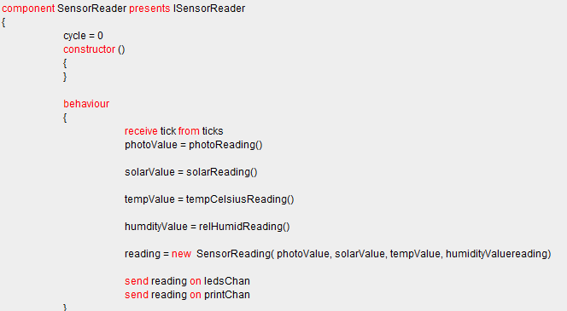

Figure 4.4: Intermediate Notation - Component example

|  |
| --- |
| <component>  <attribute name="*SensorReader* "/>  <presents name=" *ISensorReader* "/>  <field name=" *cycle* " type="" value=" *0* "/>  <constructor/>  <behaviour>  <receive from="ticks" identifier="tick"/>  <variable bindingTo="photoReading()" name="photoValue" new="false" type=""/>  <variable bindingTo="solarReading()" name="solarValue" new="false" type=""/>  <variable bindingTo="tempCelsiusReading()" name="tempValue" new="false" type=""/>  <variable bindingTo="relHumidReading()" name="humdityValue" new="false" type=""/>  <variable bindingTo=" SensorReading( photoValue, solarValue, tempValue, humidityValuereading)" name="reading" new="true" type=""/>  <send identifier="reading" on="ledsChan"/>  <send identifier="reading" on="printChan"/>  </behaviour>  </component> |

The Component element contains an attribute element with compulsory parameter string, which is the name of the component. The other compulsory child nodes are presents, constructor, and behaviour. Optional child nodes are procedures and fields.

Presents element contains only one compulsory attributes with string parameter. It describes the interface that component presents. One component could have multiple children of element presents. The correct order of presents is immediately after the attribute name of the component.

Field element contains three attributes: type that specifies the type of the field, name that specifies the name of the field, and value that specifies the information of the field. The correct order of the attributes are as they are illustrated on the example. The attributes type and value are optional.

Constructor element is a compulsory child element of component. The constructor element does not contain any attributes. The possible child elements of the constructor could be field, variable, if, send, receive, print, and expression.   
  
Behaviour element is a compulsory child element of component. The behaviour element does not contain any attributes. The possible child elements of the constructor could be field, variable, if, send, receive, print, and expression.

Send element contains three attributes: identifier, value and on. The attribute value is required only if the sending information is not specified (see the second example). The other two attributes are compulsory. In a case of primitive data type such as integer or real, identifier value could be empty and the information is stored at on attribute.

Receive element contains two attributes: identifier and from. Both of the attributes are compulsory. In a case of primitive data type such as integer or real, identifier value could be empty and the information is stored at from attribute.

Variable element contains several attributes: variable type, name, new for a static or dynamic memory allocation, binding to the constructor and the parameters.

Figure 4.5: Insense Source code - Instance example



Figure 4.6: Intermediate notation - Instance example

|  |
| --- |
| <instance component=*"SensorReader"* name=*"sr"* /> |

Instance element contains two attributes: component and name. Both of the attributes are compulsory. The first attributes contains the component which is going to be instanced. The second one contains the name of the object itself.

#### Connect

Figure 4.7: Insense source code - Connect example



Figure 4.8: Intermediate notation - Connect example

|  |
| --- |
| <connect >  <from name = *"sr"* on = *"ledsChan"*/>  <to name = *"lo"* on = *"input"*/>  </connect> |

Connect element does not contain any attributes and it has a set of two related child elements from and to. Both elements contain the information that is going to be sent. In a case of primitive data type, name value could be empty and the information is stored at on attribute.

#### Struct

Figure4.9: Insense source code - Struct example



Figure 4.10: Intermediate notation - Struct example

|  |
| --- |
| <struct>  <attribute name = *"sensorRading"* />  <field type = *"integer"* name = *"solar"*/>  <field type = *"integer"* name = *"photo"*/>  <field type = *"real"* name = *"temp"*/>  </struct> |

Struct element contains an attribute element with compulsory parameter string which contains the name of the struct. The other possible child elements of the constructor could be field.

Due to the word limitation of the chapter and considering the main goal of that section which is to illustrate the syntax of the intermediate notation, the rest of the elements are represented in the appendix at the end of the dissertation.

### **4.6 Validation of the XML intermediate notation**

At the initial stages, when XML examples were hand written to test and evaluate the system, a web validator websites were used to prove the validity of the XML syntax. The main one was XML validator (<http://www.xmlvalidation.com/>). In a later stage, the dissertation itself defines a validation procedure to trace the models for errors.



# Chapter 5: Conformance Checking



This chapter outlines and gives an overview of the conformance checking and internal validation used to build the software product. The first sections highlight the XML schema and the whole conformance checking of the input intermediate notation document. The rest of the sections explain the post parsing phase, the validation of the container objects.

### **5.1 Java and XML conformance techniques**

Java poses several validation report techniques. Different versions of the parsers support different schema languages some of which are DTDs, the W2C XML schema languages, etc. From the 5th version Java adds a uniform validation programming interface (API) that can compare documents to schemas written in these and other languages. [16]

Following example illustrates the point made, it is written in Java and demonstrates the way of validation and conformance used in the application.

Table 5: Java XML conformance checking example

|  |
| --- |
| // 1. Lookup a factory for the W3C XML Schema language  SchemaFactory factory =  SchemaFactory.newInstance("http://www.w3.org/2001/XMLSchema");    // 2. Compile the schema.  // Here the schema is loaded from a java.io.File, but you could use  // a java.net.URL or a javax.xml.transform.Source instead.  File schemaLocation = new File("/opt/xml/docbook/xsd/docbook.xsd");  Schema schema = factory.newSchema(schemaLocation);    // 3. Get a validator from the schema.  Validator validator = schema.newValidator();    // 4. Parse the document you want to check.  Source source = new StreamSource(args[0]);    // 5. Check the document  try {  validator.validate(source);  System.out.println(args[0] + " is valid.");  } |

This technique works well if the file needs to be verified as a correct XML syntax. However, for the full validation of a defined intermediate notation, specially defined XML schema must be created. In the next section it will be presented how the above described API of Java will be used with a defined schema for this project.

### **5.2 XML schema**

This section briefly will explain the current Intermediate notation schema and the most critical points and decisions made to its creation. The schema was validated throughout the whole development phase both in eclipse and on the following web site with the notation itself: <http://www.utilities-online.info/xsdvalidation/#.U_XnGvldWSp> . This process was necessary to prove that both XML notation and schema are following the current W3School standard.

The schema validates all the essential computational units supported by both upper and bottom layers. As an example ‘struct’ Insense type will be illustrated.



|  |
| --- |
| <struct>  <attribute name="sensorReading"/>  <field name="photo" type="integer"/>  <field name="solar" type="integer"/>  <field name="temp" type="real"/>  <field name="humid" type="real"/>  </struct> |

|  |  |  |
| --- | --- | --- |
| |  | | --- | | <xs:element name="struct"> | | <xs:complexType>  <xs:sequence>  <xs:element name="field" maxOccurs="unbounded">  <xs:complexType>  <xs:attribute name="name" type="xs:string" use="required"/>  <xs:attribute name="type" type="xs:string" use="required"/>  </xs:complexType>  </xs:element>  </xs:sequence>  <xs:attribute name="name" type="xs:string" use="required"/>  </xs:complexType>  </xs:element> | |

The attribute name for example is required because it describes the name of the structure. In the schema, this attribute is with status ‘required’. The XML element ‘field’ is validated against the schema with all the necessary attributes. The number of occurrences of an element is explicitly specified with min and max occurs. In a case of error, the application will not proceed to code generation.

Full version of the schema could be found at the address:   
<https://github.com/avasilsg/InsenseGenerator/blob/master/InsenseCodeGenerator/src/ConformanceChecking/schema.xsd>

### **5.3 Internal Validation**

The other validation is internal validation of the objects. This type of validation is necessary because semantics cannot be done by validating XML. Once the information is extracted and stored in the object it needs to be verified for the correctness where it is necessary. The process follows and supplements conformance checking procedure. An extensive explanation will be given in chapter 8.



# Chapter 6: Project Methodologyhttp://www.pattyscraftcorner.com/images/fancyline2.png

This chapter gives an overview of the software methodologies (processes) used to build the software product. There are several processes mixed throughout the whole period of development including Agile, Iterative and Waterfall. Moreover, source control system was used to track the changes and contain the source code.

The lifecycle of the software development outlines the main phases from the initial idea of creating a product to deliver it on time and with of acceptable quality. There are several software processes used in specific domain fields, such as Agile, Incremental, Iterative or Waterfall. The stages of the software lifecycle are shown in the Figure 6.1 overleaf, together with the input that is expected. In practice however, intentionally or not, most developers tend to choose not to follow the process strictly and sometimes some of the boundaries are blurred.

Figure 6.1: Software Engineering Process

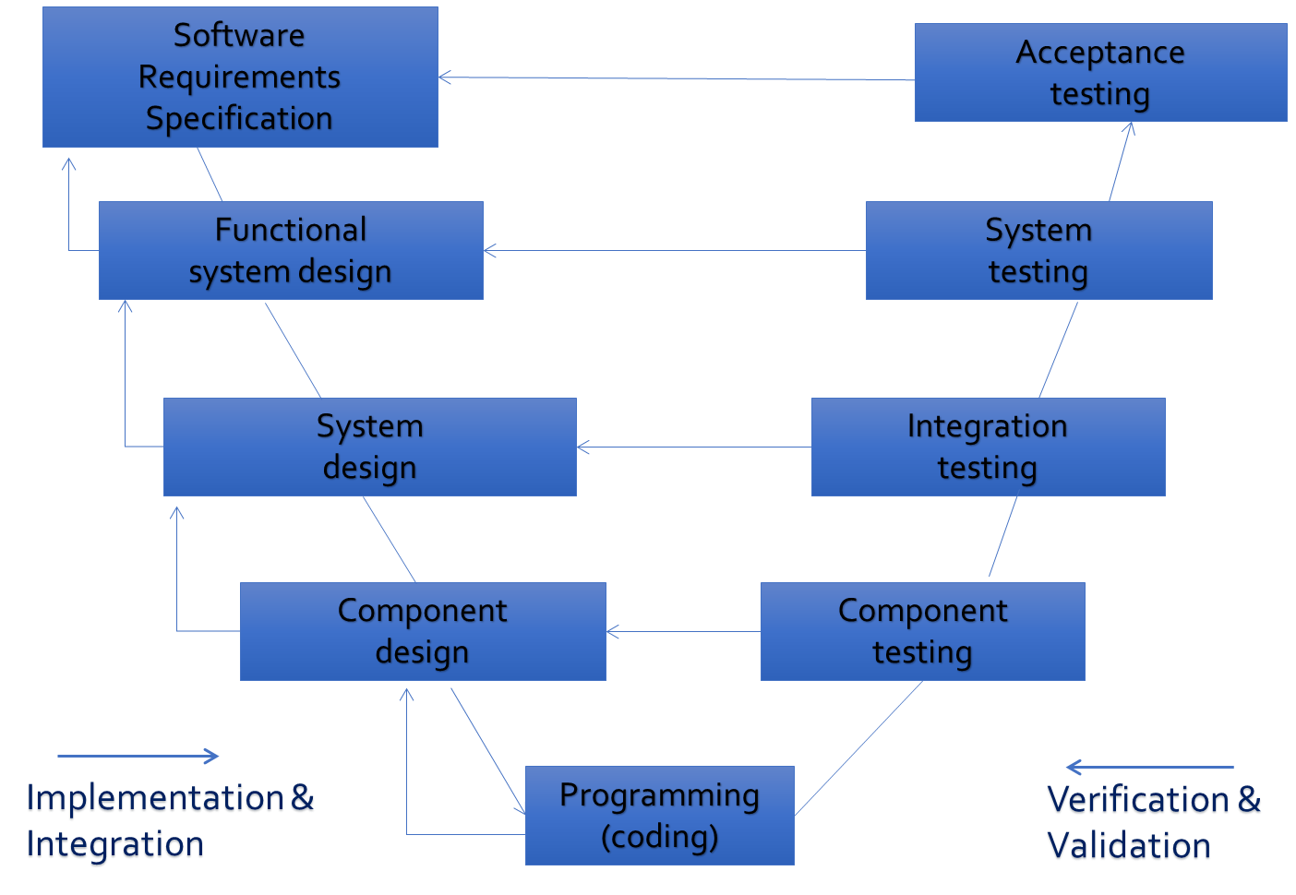

### **6.1 Agile, Iterative and Waterfall methodologies**

Three software processes were combined throughout the whole development period. The traditional software development lifecycle also known as Waterfall was followed at the early stages. Unfortunately, Waterfall itself is not very optimal if it is necessary to go back to the previous stage. For example, there were several eventual changes in the notation and some of the requirements. This imposes some restrictions on the product’s lifecycle, especially for an intensive changing of the requirements. An improved version of this software process is called Iterative lifecycle. It allows the ability to backtrack to some of the previous stages. However, even then this methodology puts the test and evaluation phase as one of the last stages. That could be a great disadvantage if the project deadline is close and very often in the industry the test phase is reduced a lot.

Agile methodology is the third software process that is partially used. Agile requires in every week of development to have a refactoring day as well as code reviews. It also requires the project to be divided in small pieces to be implemented step by step. The project was divided in small steps, and code reviews were made to some extent in the weekly meetings.

### **6.2 Software Team Work Process**

The meeting were arranged once a week to deal with integration and justification of the intermediate language. Throughout the demo preparation period, the meetings occur more than once a week for the sake of better understanding of the whole system. When necessary pair programming was performed. In the final few weeks both students acted under an extreme programming agile process.

### **6.3 Software Prototyping**

The method of software prototyping was both considered and used to fulfil the architectural drivers or, in other words, the key requirements that cover the primary objectives. The version of the prototype can be found in the source control site in the folder prototype:

<https://github.com/avasilsg/InsenseGenerator/tree/master/InsenseCodeGenerator/src/Prototype>

The architecture of that initial version was simple enough to be implemented for short period of time but enough to demonstrate clearly an attempt to fulfil all the primary objectives. Three Insense computational units were implemented Structure, Interface and Component. The implementation will be discussed later in chapter 8.

The prototype version was written in Microsoft C# programming language and demonstrated at the first practical demo of the project. The prototyping method is called ‘evolutionary’ because it also was an initial baseline for the project in a later stage.

### **6.4 Project Management Techniques**

In each software development process, version control, also known as source control, needs to be used. The main idea of the version control system is to provide a mechanism of managing the source code and create different branches if it is necessary to contain different specially adopted versions of the project (for example – a version with specifics for Windows, Linux and Mac OS). Version control can also be used for reverting back to a previous version if such a thing is necessary. With a source control system, the project is traceable and very well maintained. Of course, good committing titles and explanations are of great help as well. The selected version control system is GitHub. In addition to local storage, the project was also backed up to MS Sky Drive and Google Drive.

### **6.5 Conclusion**

This chapter covers the information about software processes, techniques and methodologies used throughout the period of project development. Another aspect that was covered is about the prototype used for an initial version as well as source and build controls systems as a project management techniques.



# Chapter 7: System Designhttp://www.pattyscraftcorner.com/images/fancyline2.png

This chapter presents the architecture and the design of the system including a set of all the necessary diagrams. All of the diagrams describe the design from a different perspective and the selected architectural model is ‘4 + 1’. [13] The views presented in this chapter include scenarios (use case diagrams), logical, process, physical and development. UML and Microsoft Visio are used to represent each view.

### **7.1 Planning stage**

At the planning stage and especially after the prototype the guiding principles could be based on a set of decisions. In this system, the following decisions were prioritized in order to select the architectural styles:

1. Quality principles
2. Encapsulation: The information must be hidden and wrapped. This practice is adopted by Object Oriented Programming (OOP) and design. Moreover, it allows implementation changes, increaseS reliability and keepS single logical unit of information concealed within an object. When the information either XML or Insense is parsed, it will be hidden within a particular object. In other words, the object could transmit the information both languages expected. Therefore, a layered architecture and an object oriented architectures will be adopted to satisfy this decision.[14]
3. Abstraction: The level of abstraction is expectED to be as high as possible and information to be easily modified and extended if it is necessary. A high level of abstraction will also allow grouping some of Insense units according to their nature and similarities. In that case, an object oriented architecture to satisfy this requirement, will be used.
4. Modularity: It is a good practice to keep each object independently maintained. In case of modifYING the content within the object, the rest of functionality will not be affected. The system must be modular with loosely coupled modules.
5. Re-usability: With object oriented approach some functionality is reusable. Good design practices require accessing functionalities from different parts.
6. Extensibility: The system has to allow easily adding new data structures, components and modules.
7. Flexibility: system allows multiple files generation. Moreover, unless the files are kept with different names, the executable source code could be combined in the solution folder. In that way, for example, unicast communication could be testED and verified.

This section explains the basic system workflow including the input file from the upper layer, verification of the file, and generation of Insense source code. In figure 7.1.1 is highlighted on a basic level OF the general architecture overview. The graphical user interface accepts the input file written in XML according to the agreed intermediate notation. The second layer contains verification and parsing functionality. Once the information is extracted, data layer generates output files and invokes the compiler.

Figure 7.1.1: General overview

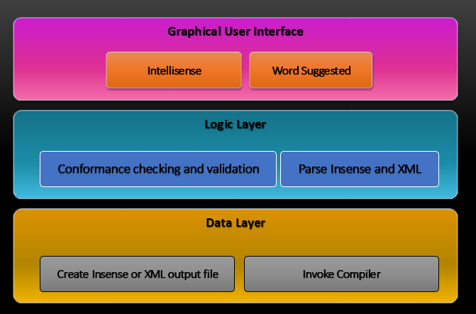

In figure 7.1.2 is presented the way of processing information according to initial idea of the project to generate an Insense source code from a model output file.

Figure 7.1.2: Basic System Workflow

The appropriate architectural model for that sequence of actions is pipe and filter. [2] The following table summariseS selected architectural styles.

|  |
| --- |
| Architectural styles |
| Pipe and filter |
| Object oriented architecture |
| Layered architecture |

THE Next chapter will describe in a detailed WAY how the architectures will guide the implementation. Meanwhile, THE next several sections will illustrate the above described overview from different perspectives.

### **7.2 Architecture specification**

The next sections start digging in the detailed design of the architecture or the core of the system. Before jumping there, it is worth showing an overview of the high – level system functionality. The diagram below is the entrance to the system design and shows where the whole functionality is accommodated.

|  |
| --- |
| Figure 7.2.1: Architectural Overview |

The modules with the same colour of the line are based on the same layer. Each layer HAS A dependency of the layer below it. Given the criteria mentioned earlier in Section 7.2, the selected architectures are layered, object oriented and pipe and filter. There are many others existing, such as Client – Server, Blackboard, pi calculus but they were not selected.

In diagram 7.3.1, both parsers are on the same level because the application supports Insense and XML generation. Furthermore, in the layer below, XML and Insense writers are respectively on the same level. Finally, the compiler for Insense is below all of layers.

### **7.3 Logical view**

The inventor of “4 + 1” view model Kruchten explained Logical View as the functional requirements perspective of the system.[13] In other words, what functionality the end – user could expect from that product. Next several sections will listed a logical architecture of the code generation application.

Figure 7.3.1: Logical Overview of the system

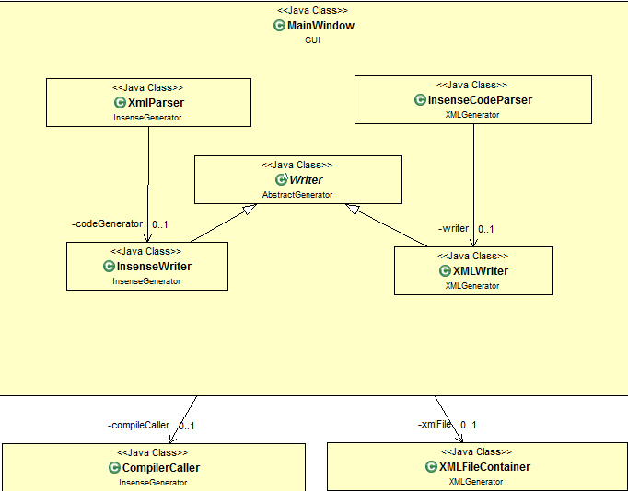

The figure 7.4.1 demonstrates in a detail how the system is developed. Within the graphical user interface (GUI) module are instantiated (invoked) both parsing modules. They invoke the corresponding writer modules. Both Insense and XML writers inherited the main writer class. Graphical user interface invokes Insense compiler and XML file container to validate the input files. The criteria for correctness of Insense is to BE ABLE TO compile. XML specification is validated against the defined XML schema.

Figure7.3.2: Detailed Logical Overview

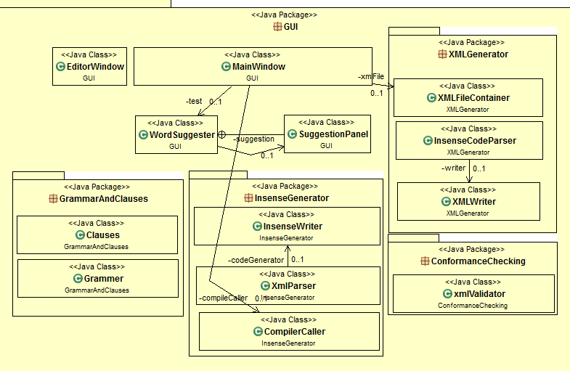

In figure 7.4.2 it can be observed that graphical user interface will have two inner or support classes for word suggesting as well as intellisense detecting and coloring the key words. Those two classes will probably receive an information from language specifics package Grammar and Clauses. The third user interface class will be editor window class which purpose will be to inform the user poping up messages from the Insense compiler.

### **7.4 Development view**

The development view describes the main components and presents the interactions between the components and external world. Of course, the level is very abstract. In diagram 7.5.1 all the components are encapsulated within the GUI. The whole communication is provided by the user interface.

Figure7.4.1: Development diagram - components

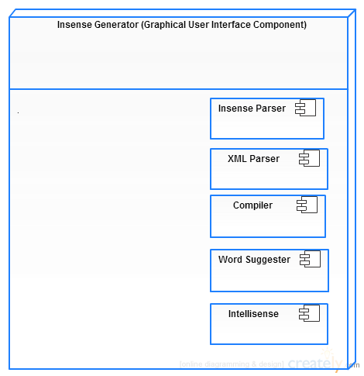

### **7.5 Process view**

Process view depicts the system from more than one perspective. Normally, here is captured the main work flow of the system, non – functional requirements and concurrency if it is applicable. [1] The view will be illustrated by two consequent diagrams – sequence and activity.

Figure 6.5.1: Main Process Flow - Activity Diagram

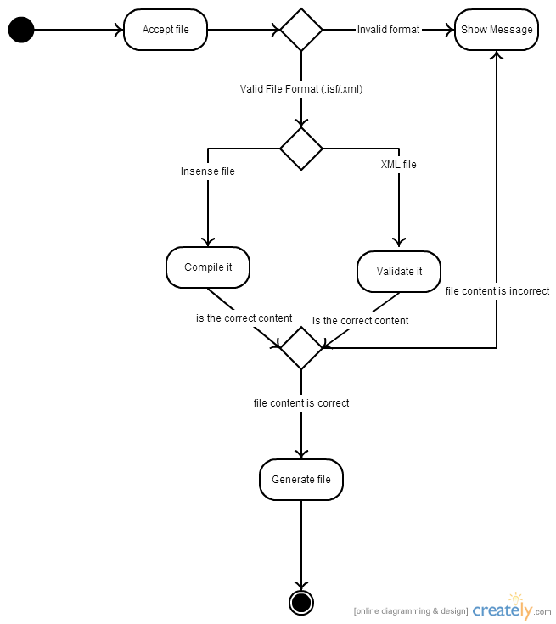

The process described in the activity diagram shown in figure 15, depicts the main functionality from the moment which input file is processed by the system until generation in a case that error does not occur. When the input file is accepted, the next step is to identify the input file extension. The graphical user interface applies a filter and restricts the variation of the input files to “.xml” and “.isf”. When a file type is identified, application selected a particular file path. The next step of the process is to validate the content. If the file is an XML, then it is verified against the schema. Otherwise, the Insense compiler is invoked to verify that file can be compiled. After the completion of verification process, the chosen parser extracts the information and distributes it to a writer component. Writers are responsible for file creation and writing. They generate the output source code. In any case of error, the user is notified by a message and the process is terminated.

Figure 7.5.2: Sequence diagram - main workflow

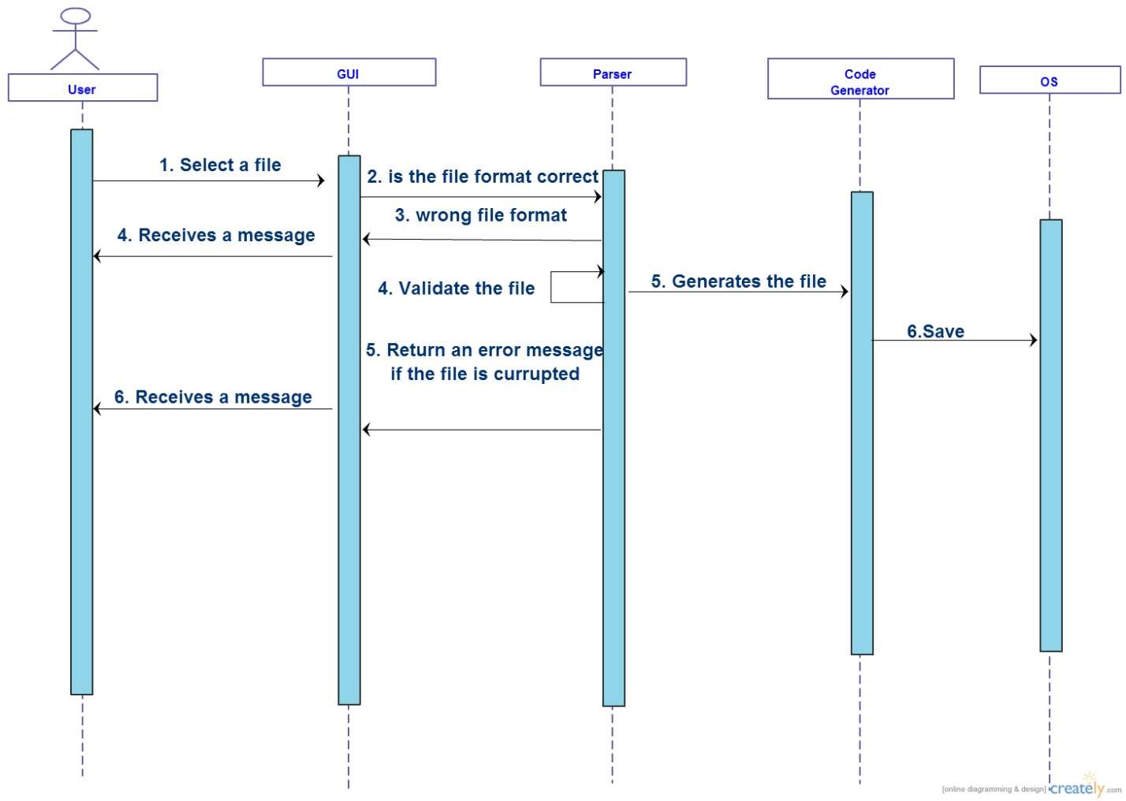

### **7.6 Deployment view**

The perspective that physical view represents is to illustrate how the system interacts with the external world. In other words, it could be considered that deployment or physical view is the system’s engineer perspective. The diagram presents the physical perspective of the system. The arrows represent dependencies between the packages. The graphical user interface package has two essential dependencies, both XML and Insense generators. The third dependency, grammar utility package is used by intellisense subcomponent to request information about keywords for colouring and suggesting them. Generators fully depend on all utility packages. They need grammar utility package to identify the correct syntax of Insense and Units utility package to store the extracted information. Meanwhile, units utility package depends on the basic units package that supportS part of the containers that IT contains.

Figure7.6.1: Deployment diagram

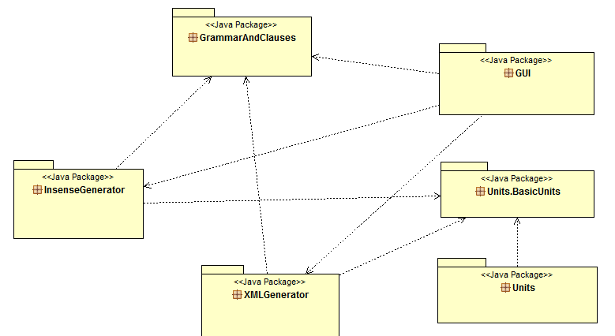

As it can be observed, the physical deployment diagram presents the system structure as interconnected nodes. For example, XML is fed to the Code Generator via the user interacting with the GUI. Then conformance checker validates if the file is presented as an intermediate notation. The parser nodes are then activated to extract the information needed from the input file and the writers generate the output in the correct format

### **7.7 Use Case Diagrams**

The use case diagram presents a basic functionality of between the user and graphical user interface the system proposes.

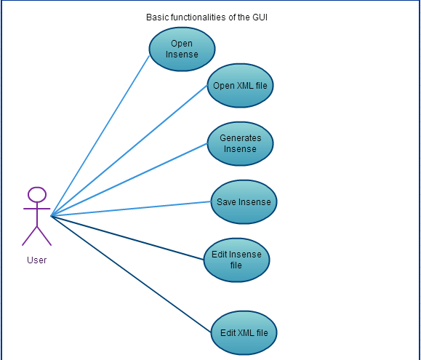

Use case diagrame demonstrates what actually the user can do with the system as a functionality.

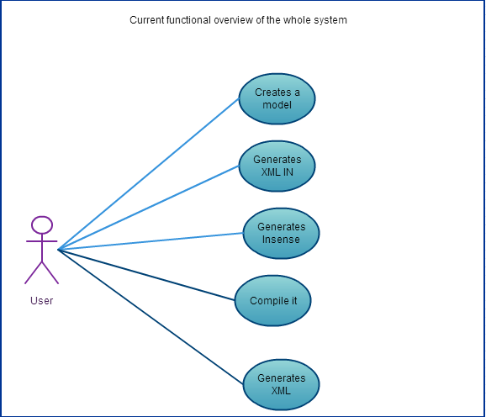



# Chapter 8: System Implementation http://www.pattyscraftcorner.com/images/fancyline2.png

This chapter focuses on the implementation strategy based on design decisions made in a System Design chapter. The sections are categorised according to the computational part they are responsible for. The first section explains the utility classes, the second section focuses on the Insense Code Generation, and the third section describes the intermediate notation generator. Section 8.4 outlines the graphical user interface. Finally, some tough implementation decisions encountered are discussed.

### **8.1 Utility classes**

This section briefly outlines the utility classes. They are divided in two categories according to their purpose. The category Bridge Classes highlights the container classes that correspond to Insense computational units shortly described with the intermediate notation in chapter 4. The next subsection explains briefly THE clauses necessary to generate the Insense source code itself.

* 1. Bridge Classes (Containers)

Container classes are derived from object oriented software architecture. They will be used to store the information corresponding to Insense computational structures such as components, interfaces, structs and different operators. The other advantage of using object containers relates to the fact that intermediate notation attributes described ARE generated from a model . With class containers this problem is sorted out. Moreover, when the information is stored in a container class, an internal validation is applied to reduce the possibility of errors. The following subsection presents the unit containers and their hierarchy.

* + 1. Basic unit containers

Basic unit containers represent channels, operators and fields. They store the information necessary TO generate and represent their Insense corresponding unit. The section represents the operators and compareS them with their Insense and XML variant.

The operators are derived from an abstract class ‘Operator’. The inheritors of operator class are send, receive, variable, print, array, return, and if. The operator class simplifIES the problem with occurring each of the statements in any order in a program. The object oriented architecture allows instead of multiple array lists, to hold all the occurrences and tracking their order to have a single array list of parameterised <operator> which is their super class and trackS their order of presents. In figures 8.1 and 8.2 are presented the relationships between the operator and the other derived statements.

In that way designed, the containers take an advantage of object oriented model aspects in a way in clarity, simplicity and extensibility.

Figure 8.1: Classes in Basic Units Module

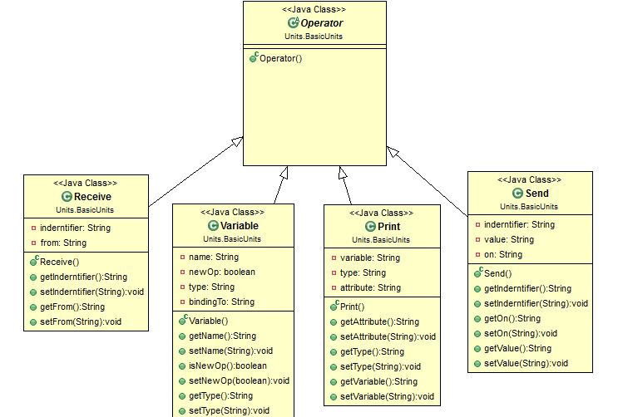

Table8.2: Classes in Basic Units Module

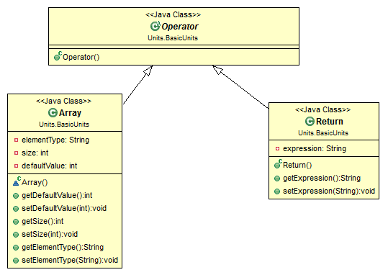

The class Send represents an Insense send operator and contains three fields: identifier, value and on. The fields contain the information extracted from Insense or XML specification. To make a point I will compare the context of class Send (figure 8.3), the intermediate notation representation and the original statement in Insense.

Figure 8.3: Send implementation representation

|  |
| --- |
| <send identifier="reading" on="ledsChan"/> |
|  |
|  |

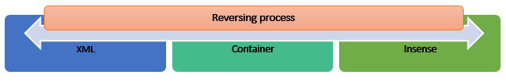As it can be observed, the all three representations are absolutely identical. That is necessary to transmit information from XML to Insense and vice versa. The following diagram depicts the main idea, applied over the whole application.

Figure 8.4: Information transmitting way

The class receive follows the same convention. However, print, return, array and variable are not that alike. They are presented as starts from Print.

Table 8.5: Print Implementation Example

|  |
| --- |
| <print type="string" variable="'Cycle '"/> |
|  |
|  |

Print container includes two important characteristics. The first is related to the escaping the symbol quote. That is necessary due to the limitation of the input XML specification. The second is concerning the functional call itself. According to the data type print will identify what type will represent.

Variable container stores the information from a data unit defined inside the body of the constructor, behaviour or procedure.

Table 8.6: Variable container example

|  |
| --- |
| <variable bindingTo=" SensorReading( photoValue, solarValue, tempValue, humidityValuereading)" name="reading" new="true" type=""/> |
|  |
|  |

The rest of the statements are very similar to above describeD ones, and will not be fully covered.

Chanel container is the first non ‘operator’ derived container that will be presented.

Figure 8.7: Channel container example

|  |
| --- |
| <channel type = *"sensorReading"* name = *"printChan"* direction = *"out"*/> |
|  |
|  |

Channel container stores the information parsed by Insense Parser and XML Parser. After the validation the information is processed. There are three field types, name and direction already described in the intermediate notation chapter. At the beginning of the container are desclared two constant variables. They are used for validation of the directions.

The component behaviour, constructor and procedure shared similar behaviour. For that purpose was designed A class body that is a superclass of all three of them. The class body itself contains a list of operators. The main idea is to track the occurance of a different statements (see figure 8.8).

Figure 8.8 Body hierarchy

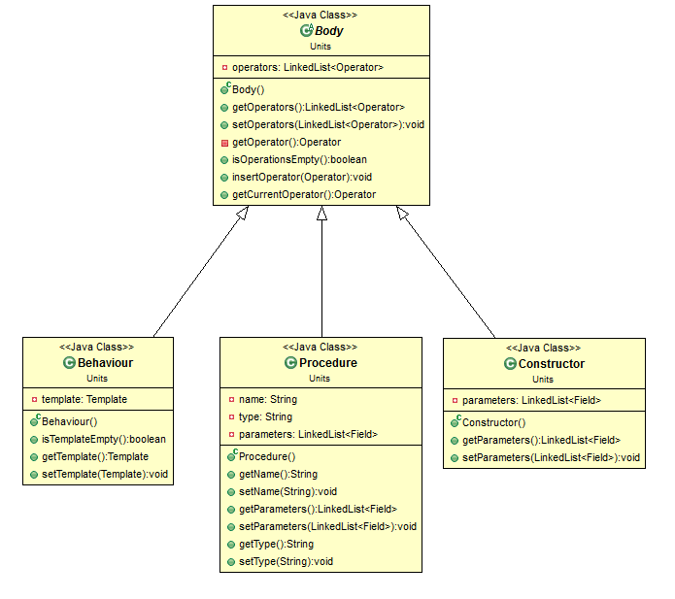

Table 8.9: Hierarchy in Unit Module

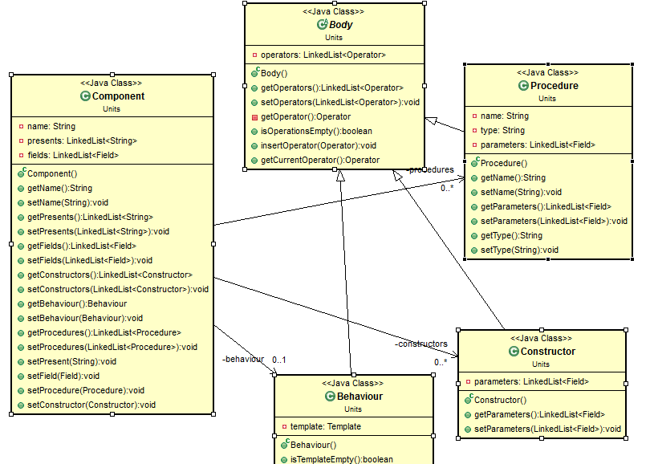

Interface container stores the information parsed by Insense Parser or XML Parser. It is described by two fields, the first one represents name of the interface, and the second one is a list of the basic unit type container channels, briefly described in before.

|  |
| --- |
| <interface>  <attribute name = *"ISensorReader"* />  <channel type = *"bool"* name = *"ticks"* direction = *"in"*/>  <channel type = *"sensorReading"* name = *"printChan"* direction = *"out"*/>  <channel type = *"sensorReading"* name = *"ledsChan"* direction = *"out"*/>  </interface> |
|  |
|  |

Component container stores the information parsed by XML and Insense parsers. It is described by name, presents, fields, behaviour, constructors and procedures. The field name stores the name of the component. The list represents the interfaces that component implements. The list fields represents the fields of the component and the lists of procedures and constructors represents the corresponding computational units.

|  |
| --- |
| <component>  <attribute name="*SensorReader* "/>  <presents name=" *ISensorReader* "/>  <field name=" *cycle* " type="" value=" *0* "/>  <constructor/>  <behaviour>  <receive from="ticks" identifier="tick"/>  <variable bindingTo="photoReading()" name="photoValue" new="false" type=""/>  <variable bindingTo="solarReading()" name="solarValue" new="false" type=""/>  <variable bindingTo="tempCelsiusReading()" name="tempValue" new="false" type=""/>  <variable bindingTo="relHumidReading()" name="humdityValue" new="false" type=""/>  <variable bindingTo=" SensorReading( photoValue, solarValue, tempValue, humidityValuereading)" name="reading" new="true" type=""/>  <send identifier="reading" on="ledsChan"/>  <send identifier="reading" on="printChan"/>  </behaviour>  </component> |
|  |
|  |

Struct container stores the information parsed by Insense Parser and XML Parser. It is described by two fields, the first one represents name of the interface, and the second one is a list of the basic unit type container channels, briefly described in previous table.

|  |
| --- |
| <struct>  <attribute name="sensorReading"/>  <field name="photo" type="integer"/>  <field name="solar" type="integer"/>  <field name="temp" type="real"/>  <field name="humid" type="real"/>  </struct> |
|  |
| |  | | --- | |  | |

Body is an abstract class. It contains a list of operators. The main idea of that list is to track and store statement occurencies within a body structure. Body is a parent of Behaviour, Constructor and Procedure.

Behaviour contains a list of operators. It was fully implemented and verified due to the fact that component is the main computational unit of Insense for handling information.

Procedure container stores alike function alternatives in Insense structures. Procedure is described by name, type and arguments. The body of the procedure in Insense similar to components behaviour can contain a wide range of operators occurring in different order. That is the reason container procedure to be derived from Body class. Code generator supports both local (defined within a component) and global procedures.

* 1. Other utility classes

XMLFileContainer contains the file path and file name of currently opened XML file. XML file container is important for Graphical User Interface layer, when the user saveS the file in a location different thAn default one. It is also important for XML parser in case the file will be parsed and generated. XMLFileContainer is AN update from both layers – the GUI when new XML file is opened and the XML Generator.

InsanseFileContainer contains the file path and file name of currently opened XML file. XML file container is important for Graphical User Interface layer, when the user saveS the file in a location different thAn default one. It is also important for XML parser in case the file will be parsed and generated.

Overall Object – oriented software architecture increased system reliability, simplified the logic and reduced the source code. It also saved time for both implementation and validation. The rest of the section will illustrate that point with an example. The table below describes the main body of the component behaviour.

### **8.2 Insense Code Generation**

This section briefly explains the Insense Generator module and the three associated WITH IT classes . The following table lists them.

InsenseGenerator.*XMLParser class*

XML parser extracts Insense application definition as encoded by the UML modeling tool in XML. Before starting the process of parsing, conformance checking is applied over the input specification files to verify XML corectness. The process of parsing starts with instantiating Insense writer. The XML Parser class is following algorithm: the first step is to validate the file against the schema. Once the input specification is proved valid, the parsing process begins. When a computational unit is found and fully processed, the generator acceptS this structure and generated it as an Insense source code. Under computational unit XML parser understands interface, struct, component, instance and connect.

According to selected architectural model pipe and filter, the XML Parser is a filter between two pipes. The input and output files are pipes. From a software architectures’ perspective XML Parser is a connector of two components. The advantage of XML Parser is that it internally verifies FOR ERRORS to some extent .

InsenseGenerator.*InsenseWriter*

Insense writer publishED in a file special typed strings that come from Utility class Clause. These strings represent an Insense language syntax. For writing stream in this class is used java writer. The other important element related to Insense writer is that here is made the identation. In opther words, Insense writer tracks nested levels.

Compiler Caller

The compiler caller class invokes the selected type of compiler and passes the generated file as an argument. It also collects the runtime information and monitors to identify if the compilation is successful.

### **8.3 Reverse Engineering**

XMLGenerator.*InsenseParser class*

Reverse engineering module is very similar to above described of Insense Code Generation one. Insense parser class is responsible for identifying and extractING the necessary data from an Insense program and to store it into the container classes. The limitation in the parsing process comes from the fact that XML parser fully relies on the identation of the program or in otheR words, the followed convention which is described in section 8.5.

As the diagram 7 depicts below, even the mEthods of both parsers are identical. The way of processing the input information, however, is different. In Insense parser class, the source code is read as lines of Strings. The first step is to split the line with delimiters escaping symbols and brackets. The second step is to identify iF the expression contains a key word. According to a Insense syntax the rest of the process is almost clear. The fields are filled with the information against the particular statement.

Since reverse engineering was not a primary objective of the initial dissertation project, the priority given to that module of the system was low. The current condition of the reverse engineering process is that Insense parser is able to generate all the essential computation units. It also supports fields, print, variable, send and receive operators.

Figure 7: Insense Parser

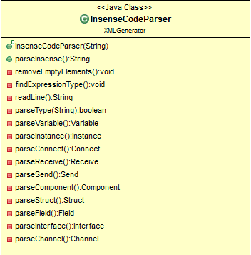

XMLGenerator.*XMLWriter class*

The XML writer also has similar structure as a Insense Witer class. Both writer classes transmit information with a help of the utility containers. The difference comes from the fact, THAT this time the parsed data from Insense is written in XML. For the whole manipulation of create and write an XML were used the latest XML libraries supported by Java seventh version.

### **8.4 Internode communication**

Inter node communication allowS two or more nodes to send and receive signals from each other by typed radio channel. Internode information is stored within a Node container. In figure 8 is shown a diagram of class Node.

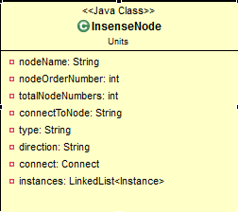

Node is characterised by name and type. Type is especially important for the Insense generator. With an information stored in type, the generator tool will know What template to use: send or receive. Once this information is available, the generator creates a whole set of radio communication template including interface with channel definitions, component, instance and connection. This generated radio communication channel is absolutely invisible for the user.

There are two round situations here with that particular situation of template generation. The first one is related to the name of the Node. It neends to be a number (unsigned integer), elsewhere the program will not compile. This is an Insense depency. The second case is when three nodes HAVE communication with each other. Two of them are senders of integers, the third one receives their information. To be able to distinguish between the two sender nodes, receive should be able to track them. For that purpose special structure with a key type is created and packed with the data.

### **8.5 Graphical User Interface**

The graphical user interface contains one main window and two inner layears that were implemented at the beginning but in a later stage were re-used. The first one is a document style that recognises and colorS the key words while the user types keys.[18] The second one is a word suggester window that helps the user to select a particular keyword. [19]

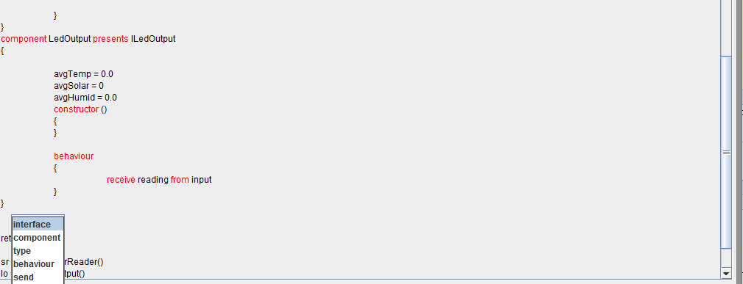

The graphical user interface actually is an integrated development environment that allows the user to edit, generate and compile an Insense source code.

### **8.6 Code convention**

The followed convention is Microsoft one.[17] This section will outline the most important and noticeable convention aspects.

1. Defensive programming: source code that protects itself. The idea will be illustrated with an example. The following table depicts one of the most common mistakes in C alike programming languages including Java.

Figure 8.5.1: Common mistake in programming

|  |
| --- |
| if (this.filledGrid[x][y] = true)  {  return false;  } |

In that case, the value true will be assigned to the matrix. The statement is absolutely legal and acceptable as an assignment operation, as a condition operation and as syntactically correct Java expression. Following defensive code practices ,the code will ‘protect’ itself and the compiler will signal for an error.

Figure 8: Defensive programming style

|  |
| --- |
| if (true == this.filledGrid[x][y])  {  return false;  } |

1. Additional conventions: classes combined in packages, the class name starts with upper case letter. The following order of class structure is constants, inner types, fields, constructors, properties, methods; Initial refactoring: no improper and meaningless variable names, formatted source code.

Convention is followed not all the time, where it is possible. The goal is to guarantee consistency and readability of the presented source code.



# Chapter 9: Testing and evaluation



The chapter presents a brief overview of testing strategIES that are used. The next several sections present a comprehensive collection of different test approaches and cases that provide acceptable evidence that testing procedures were carried out. Due to the time and space constrains not all the test cases are documented.

### **9.1 Testing methodologies**

Component (Functionality) Testing: particular modules, classes and methods were tested. An evidence of unit testing may be found in uploaded source material to that dissertation. The methodology was important because verifies the system’s functionality.

Acceptance Testing was performed because it was important to check whether the system satisfies the initial requirements. On both demos including the feedback it was confirmed that system is accepted.

Black Box Testing: without peering into an internal structure or workings, a set of UML models was processed as an input. The goal was to be examined the behaviour of the system and the quality of the generated source code.

Test planning process

In the figure 9.1 are listed the most common risk levels considered throughout the test process. The most often levelS of failure were at the beginning: lack of the quality and in a later stage, user frequency.

Figure 9.1: Risk Level Diagram

To verify correctness, the generated source code was run through the Insense compilers, according to the supported functionality. At the end of the process some examples were run through the real physical wireless sensor network devices, to verify the Internode radio communication templates.

The most important test cases could be observed in the repository. Tests were run manually at the beginning and automatically (the whole system) at the end.

### **9.2 Evaluation**

In the following section, a brief evaluation of the system shall be made. The idea is to be described the implemented system as a complete product according to the initial objectives.

### **9.3 Quality Attributes Evaluation**

* 1. Usability

The usability as a quality attribute was considered critical. The system has to be user friendly, especially for the end user. While implementing the system, this attribute was mainly prioritized throughout the graphical user interface development. The user guide of the application, accompanying with video materials, could be found in the appendixes.

* 1. OS Compatibility

Even if that quality attribute was not given high level of priority ,the system is fully compatible with all of the three operating systems. From the perspective of that application, the system is also compatible with the top layer and allows automatic code generation.

* 1. Correctness and Reliability

The last two quality attributes were verified throughout the testing and validation phases of the project implementation. By ‘correctness’, it is understood if the intermediate notation delivers incorrect information and the system is not able to detect it; there is actually a violation of the rules. As far as possible, most of the test cases went smoothly and the acceptable level of correctness is achieved at that level of systems’ completion.

* 1. Scalability

The system could be considered as a real time application. Until it is a computational unit (described in chapter 4 and chapter 8), it is generated immediately. The only information stored at the memory is the information currently processed. Scalability is an important factor and especially when a large amount of source code is generate (millions of lines). For all of the test cases and examples, the system completes code generation for milliseconds. In the appendixes it could be found scalability table with the measured time and memory of the system throughout the lifecycle.

* 1. Code Generation Evaluation

At the initial stage the system was able to generate only code stubs such as structs, interfaces and components. In a later stage, the system facilitateS the end user with generation of a large set of the most commonly used examples. Moreover, the generated code is well formatted throughout the process. Once the model is fulfilED with all of the necessary information the end user or software developer is not required to fill anything in the generated source code. However, if the statement is not defined in the intermediate notation, the system allows to be added and this does not prevent the program from successful compilation if the Insense program syntax is correct. Finally, the Insense compiler is invoked to verify that the generateD source code compiles.

* 1. Objectives achieved

The table below highlights the main list of objectives together with the level of what they have been achieved. The following table describeS the convention that is used to represent the level of achievement.

Table 7: Method of achievements evaluation

|  |  |
| --- | --- |
| Abbreviation | Meaning |
| FA | Fully achieved |
| PA | Partially achieved |
| NA | Not achieved |

|  |  |
| --- | --- |
| Objective | Status |
| Propose a set of defined rules that describe a model with all the architectural properties and their values. The notation should be detailed enough to ensure mapping between the UML model and the Insense code. The objective is concerned with identifying violations, ambiguities and level of compatibility. | FA |
| Design and Implement an Insense code generator. The generator will take a representation of an Insense application as a UML model as input and will generate the corresponding Insense source code. | FA |
| Domain specifics - Identifying specific industry standards for code generation and adoptING them. | FA |
| Develop a conformance – checking framework (schema) to prevent incorrect code generation and detect all the violations in the notation. | FA |
| Build a model and provide a detailed validation process. Develop a model that will be verified and evaluate the proposed application and functionality. | FA |
| Integrated Development Environment (IDE): Develop a simple graphical user interface that allows the user to open intermediate notation, validate it, generate Insense source code and compile it. | FA |
| Reverse Engineering: Develop a simple essential reverse-engineering strategy that allows generation of the essential computational units of Insense to Intermediate notation. | FA |
| Intellisence: Provide a basic mechanism for identifying and colouring the key words and suggesting possible (guessing) keyword as well as formatting the source code. * | PA |
| Adapt the developed IDE from the secondary objectives as a plugin (graphical part embedded to Eclipse) to increase the compatibility between the projects (layers). | FA |

* As an addition, the GUI is not only able to identify and colour the words, but it also recogniseS them while the user types the source code. (Real time intellisense improvement).

Additional achievements:

|  |  |
| --- | --- |
| Objective | Status |
| Develop an internode radio communication single sender / receiver. | FA |
| Develop an internode radio communication multiple senders / receiver. | FA |
| Develop a special plugin version of the application that is embedded in the upper layer. | FA |



# Chapter 10: Conclusionshttp://www.pattyscraftcorner.com/images/fancyline2.png

In the final chapter of the dissertation, a brief overview of the goals, future work and limitation of the project is specified. Finally, the last two sections express group experience, some final notes and once again summaries of the achievements obtained in the dissertation.

The initial goal of the project was to generate from UML models Insense source code. Insense applications are composition of interfaces, structures and components that interact via typed channels. The project involved designing and implementing a code generator tool that takeS UML output written in the specified convention, and generates the Insense source code. The code could be verified by invoking an Insense compiler.

The project was developed on Java and Eclipse. The main functional units such as structures, interfaces, components, procedures, etc. were implemented. That allows simplifying the wireless sensor network application development in Insense. Moreover, inter - node channel abstraction over underlying radio communication allows the programmer to draw only a single channel connection between the components in different nodes. In this way, all the work related to system – level radio components will be generated automatically instead of written by hand.

### **10. 1 Future work and improvements**

Apart from the limitation mentioned above in the previous sections, there is room for improvement that is considered a future work. The following section introduces some of the functionality that could be added:

Improved conformance checking: due to the time limit and extensibility of the project, features conformance checking was implemented only to validate the XML. Another validation practice that tests and lexically validates the Insense itself could also be added.

Reverse-engineering could be improved in greater detail. It could include language analysis, backtrack compatibility (compatibility means the ability to be able to detect ambiguities and to avoid them, in case of violation to handle the error) etc.

Lexical analysis for error detection on the GUI side: for example if the expression is incorrect to be underlined with a red dizzy line, to be able to detect dead code. It might also include automatic correction (as well as automatic changes) if the pattern occurs somewhere within the source code.

The additional Insense language features also need to be implemented such as loops, exception handling, Insense channel operations like “select” and timers.

### **10.2 Limitations**

That section highlights some of the challenges that were not perfectly addressed due to the time limitations.

The first limitation is the fact that source code indentation (formatting) depends fully on the fact that brackets are generated on the new line.

The second limitation is due to the intermediate notation. Some of the constructions such as loops, branching, expression could be represented in a more sophisticated way.

As a summary of the work for the whole period of time, all objectives were achieved. While no proof of an absolutely bug–free project could be presented, it can be clearly stated that there is no bug found in the system and the testing and validation process was carried out to ensure that the system stability and the overall good quality are achieved.

### **10.3 Group work experience**

Group working experience was positive. The cooperation inside the team brings a lot of new knowledge and experience. When it was necessary, the problems were solved by the whole team. I personally helped with the top-layer project by building the plugin project as a baseline. Throughout the research time I was able to actually learn how eclipse plugin works which in a later stage was part of my dissertation project. Also, we cooperated through reading of UML files and generating them to XML.

The communication and meeting happened through social network Facebook and by email. The meetings were arranged when it was necessary, not desired for the sake of them. The files were shared via version control system.

The other advantage of group working was the opportunity to have two supervisors. In the weekly meetings they both came up with ideas and the brainstorming was extremely positive.

Overall, the group experience is positive and leads to the creation of bigger project, similar to the industrial ones which, for an industry such as Software Engineering, is considered to be of vital importance.

### **10.4 Conclusions**

The main idea behind the project was ‘building of Insense code generation project’. It turned out that the code generator not only can be a simple program but also it can be a whole integrated development environment with all the functionality and tools like reverse-engineering (Insense and xml generator), intellisense, conformance checking and a compiler selector according to the operating system. Moreover, this project introduced the notion of template generation for radio Inter-node channel communication. Inter-node channel communication permits the programmer to specify in UML channel connections that connect component instances on different sensor nodes. One might argue that inter-node channels can greatly simplify WSN application development in Insesne by abstracting over lower-level Insense radio communication primitives such as broadcast and unicast. This technique could be easily applied to different software communication areas.

On a personal note, this project was of great value for my professional and personal experience. Given the fact that I have never implemented code generation, intellisense or reverse-engineering before, this definitely was a step forward. A lot of additional skills and technologies were learned. The designing of the notation and schema from scratch that aimed to transmit the information and generate the workable source code ,are considered a huge challenge in software engineering with MDD and are a point of huge satisfaction and pride for me. Cooperation with the top-layer when help was necessary, helped me to get my hands “dirty” with UML 2.0 as well as plug-in development.

As a conclusion, the main, secondary and tertiary objectives of the dissertation have been successfully completed with more than satisfactory results for me.



# Reference section:

# http://www.pattyscraftcorner.com/images/fancyline2.png

1. Dearle A., Balasubramaniam D., J. Lewis, and R. Morrison, “A Component-Based Model and Language for Wireless Sensor Network Applications”, Proc. 32nd Annual IEEE International Conference on Computer Software and Applications (COMPSAC), 2008, pp. 1303–1308.
2. Gerard, S. (2014). Papyrus. [online] Eclipse.org. Available at: http://www.eclipse.org/papyrus/, visited on 9 July 2014
3. Schmidt. D., Model-driven engineering, Computer 39, 2006
4. Raghavendra C.S, Sivalingam K., T. Znati, (eds): Wireless Sensor Networks. Kluwer Academic
5. Selic B. (2003). The pragmatics of model-driven development. IEEE Software 22(5): 19 - 25.
6. Kelly S., Juha-Pekka Tolvane Domain-Specific Modeling: Enabling Full Code Generation
7. Oracle, Java Language Official Web Site, https://www.oracle.com/java/index.html], accessed: 04.08.2014
8. Press (2004). IEEE Programming Languages Ranking, [online], accessed: 04.08.2014, <http://spectrum.ieee.org/static/interactive-the-top-programming-languages>
9. XML, W3Schools, [online], accessed: 04.08.2014, <http://www.w3schools.com/xml/xml_whatis.asp>
10. GIT Official Web Site, [online], accessed: 04.08.2014, <http://git-scm.com/>
11. Maven Official Site, [online], accessed: 04.08.2014, <http://maven.apache.org/what-is-maven.html>
12. Mattingley J., Code Generation for Embedded Convex Optimization, Stanford University
13. Phillippe Kruchten., Architectural blueprints the "4+1" view model of software architecture. IEEE Software, 12(6), November 1995.
14. Software Architectures, Lecture Slides, University of Toronto, online, <http://www.cs.toronto.edu/~sme/CSC444F/slides/L19-SoftwareArchitectures.pdf> , visited on 11.08.14
15. W3Schools, [online], <http://www.w3schools.com/schema/>, visited on 25.07.2014
16. <http://www.ibm.com/developerworks/java/library/x-javaxmlvalidapi/x-javaxmlvalidapi-pdf.pdf>
17. Microsoft Convention, <http://msdn.microsoft.com/en-us/library/ms229042.aspx>
18. Stack overflow, coloring the words, online, <http://stackoverflow.com/questions/14400946/how-to-change-the-color-of-specific-words-in-a-jtextpane> , visited on 12.08.2014
19. Stack overflow, words guessing, online, visited on 18.08.2014
20. Wojcik R, Bachmann F, Len Bass, Paul C. Clements, Paulo Merson, Robert Nord, and William G. Wood. Attribute-Driven Design (ADD), Version 2.0. Technical report, Software Engineering Institute, November 2006.



Appendix A: Ethic policy 





Appendix B and C: Learning materials and Intermediate notation

Instead of putting everything in an appendixes, the whole information including Intermediate notation draft and the User Manual can be found at the local repository address in a folder documentation:

<https://github.com/avasilsg/InsenseGenerator/tree/master/InsenseCodeGenerator/src/Documentation>